Locate site action on the top left side of the PWA site

Create new site

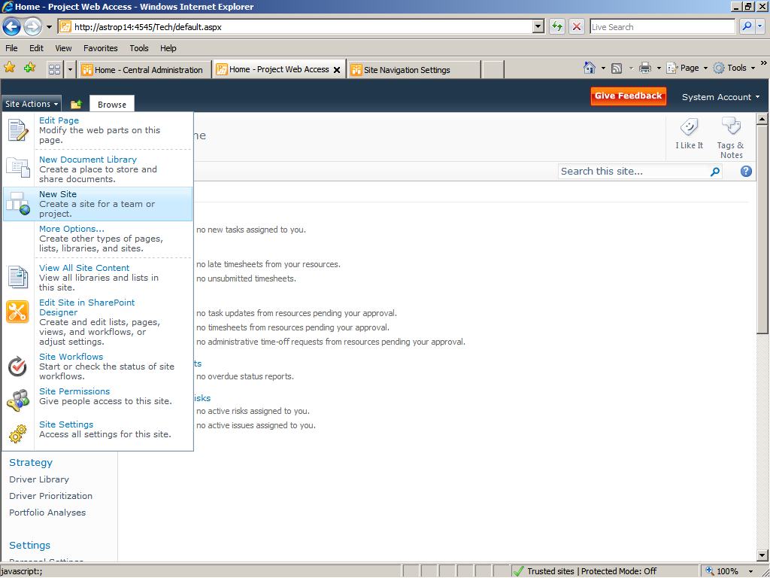

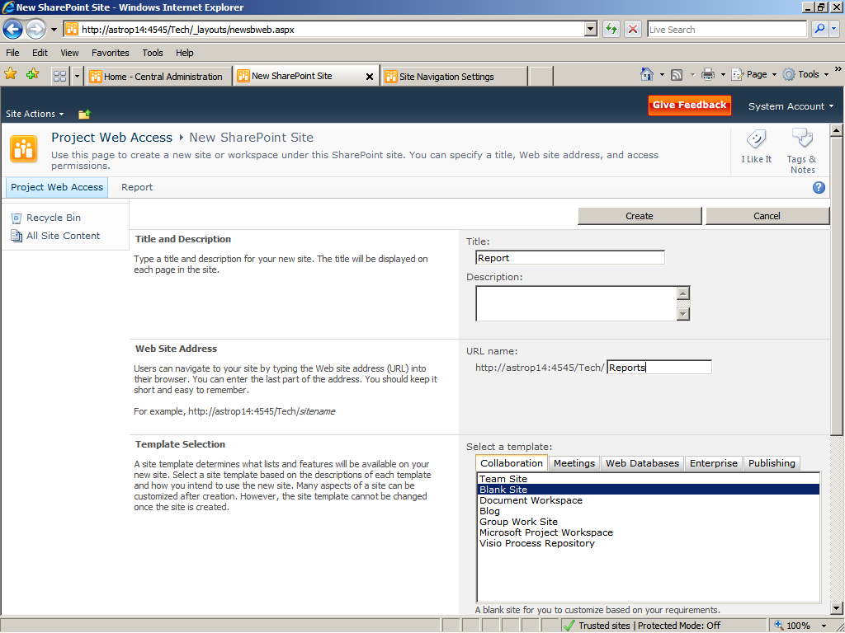

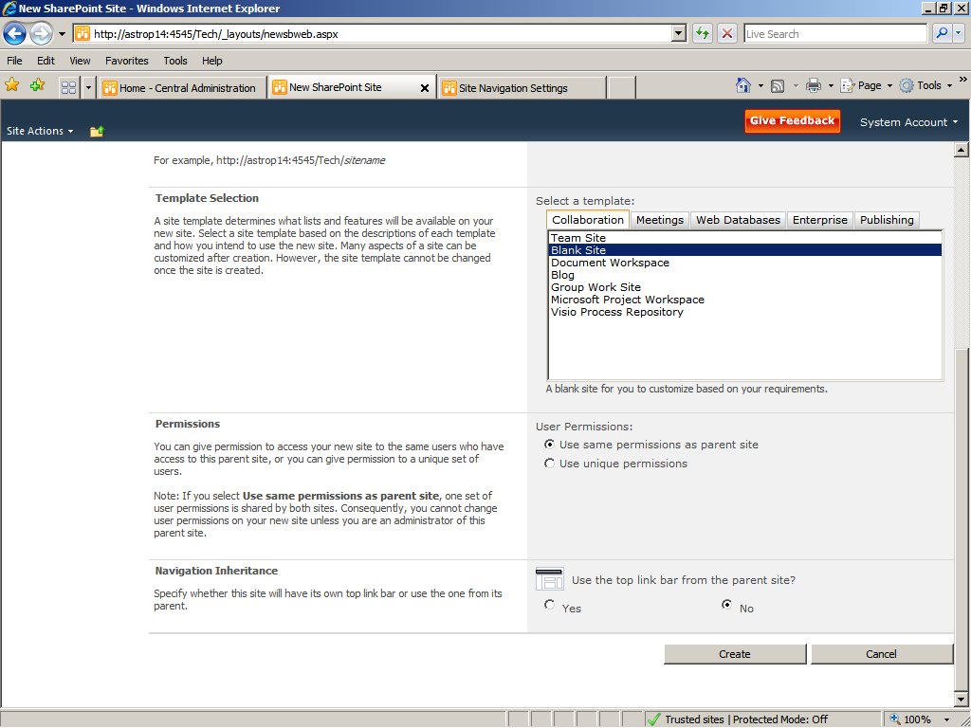

The report site will get open

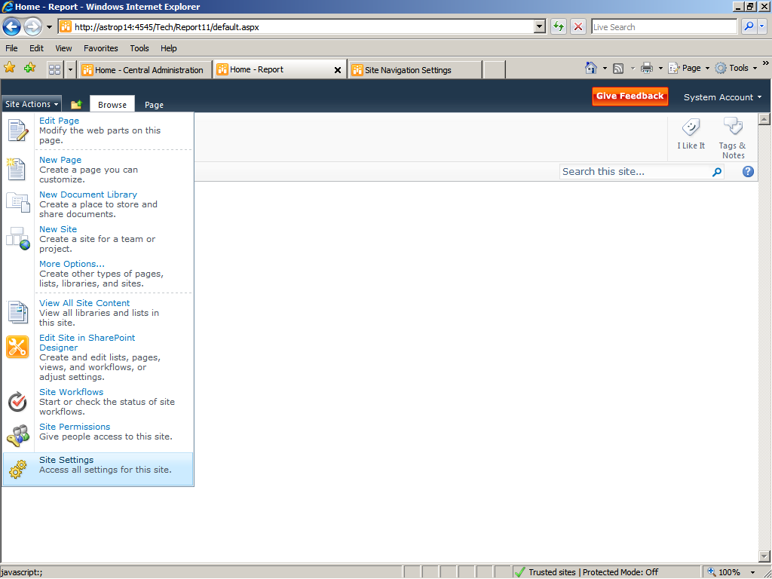

Locate site action at the top left corner of the site n click site setting

Click navigation under the look and feel tab

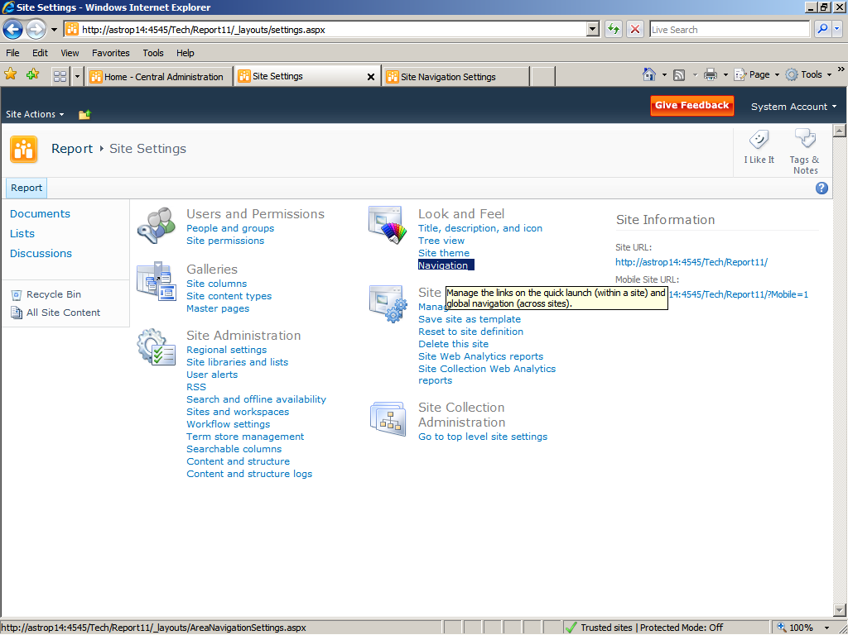

Check the show sub sites under the current navigation column

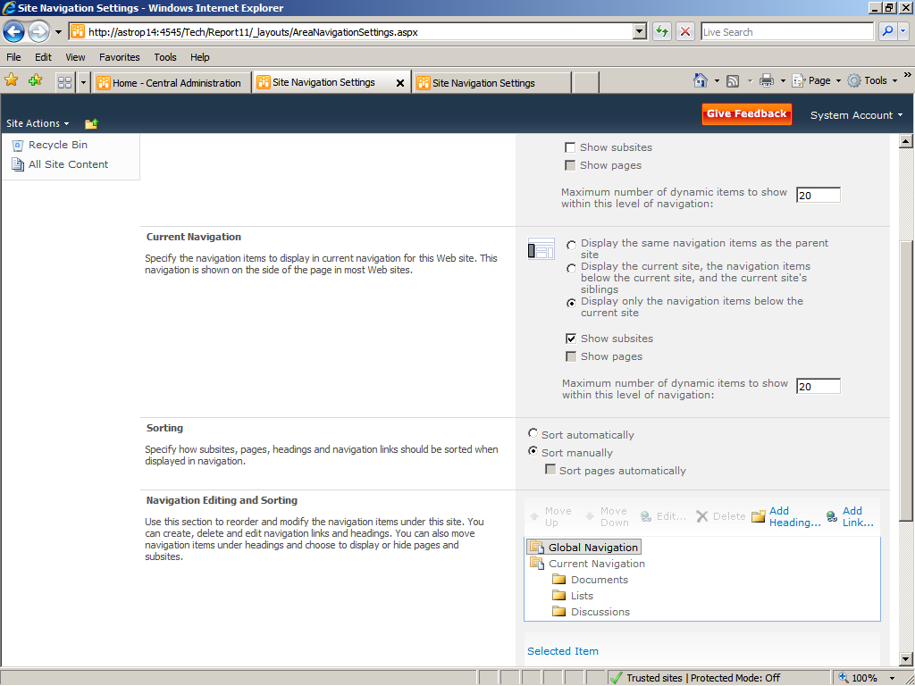

And add the report URL through the add link option for current navigation tab

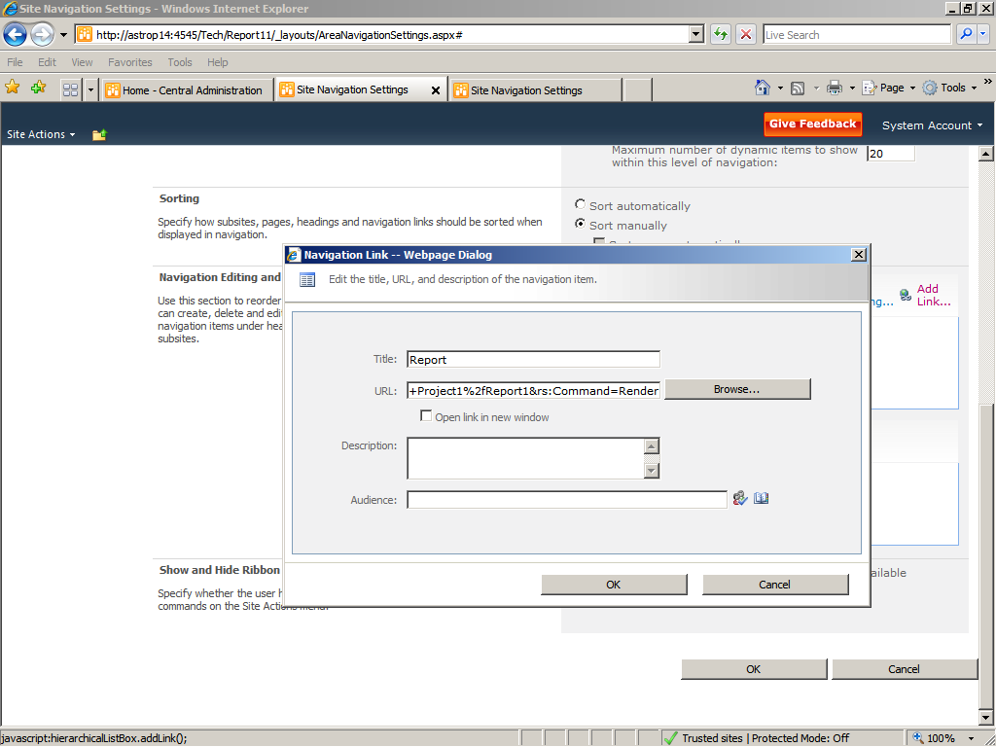

Click ok

Now in PWA site🡪Click site action(top left corner)🡪site setting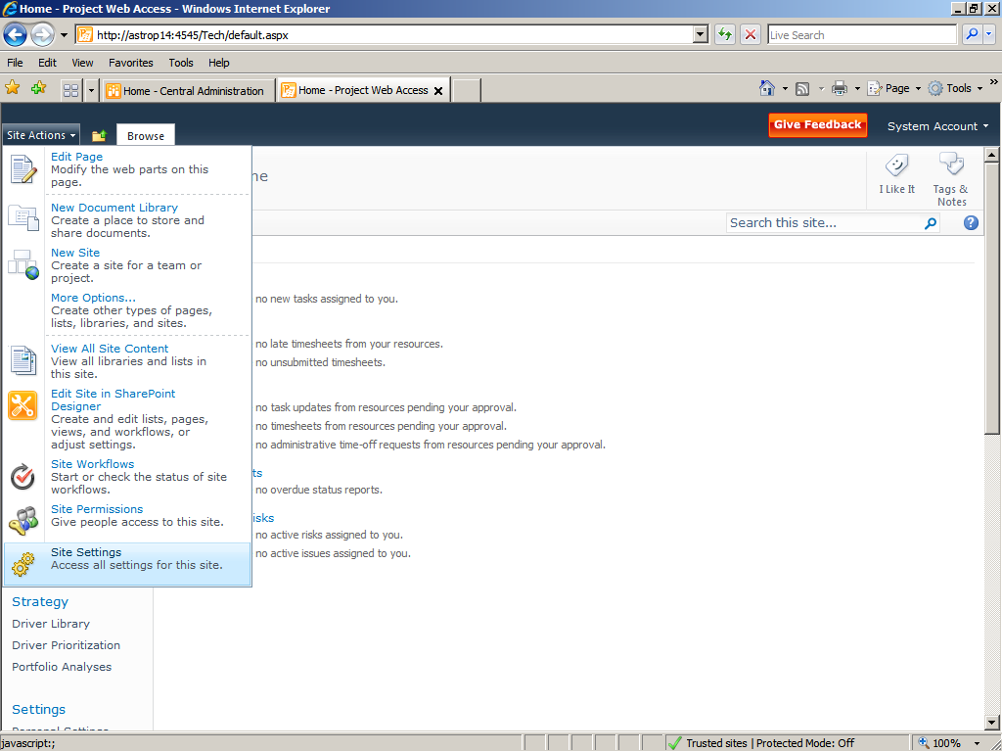

Click site navigation under look and feel tab

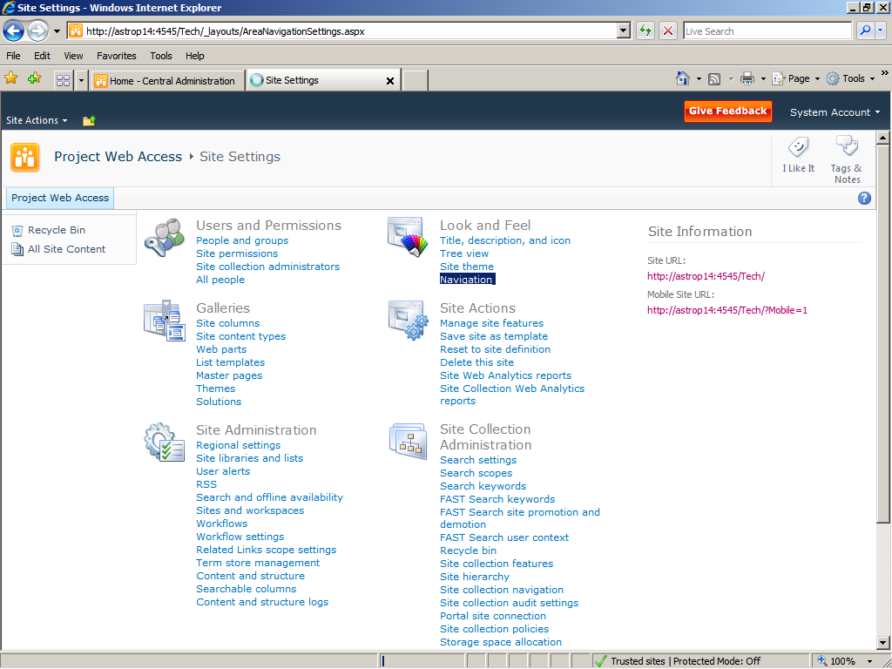

Check the show sub sites under Global navigation and add heading for the report site

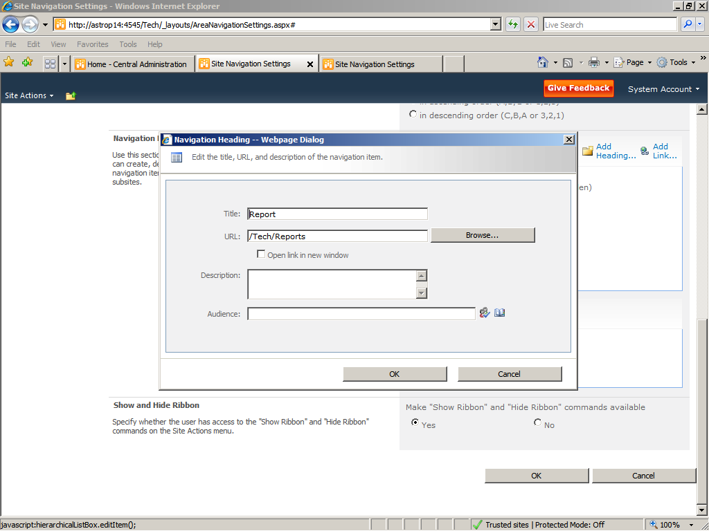

Click ok